[1]

C section polar 3D printers as cost effective solutions to desktop 3D printing

Akshat Srivastava [1] , Ninaad Bhan[1], Chitwan Gautam[1]  
Mechatronics Engineering  
Manipal University Jaipur

Ram Dayal [2]Mechanical Engineering  
National Institute of Technology, Uttrakhand

*Abstract*—3D printers have recently gained ample attention from the scientific communities. Studies are directed either towards utilization or extension of available features, but few on optimization. 3D printers can be extremely useful in the context of developing countries. Some barriers including affordability and availability pose a challenge to the latter proposal. This study focuses on structural advancement and optimization of machine design for a 3D printer. It attends some of the quiescent, yet important questions for 3D printing technology and its relation with the consumer electronic market of developing countries.

*Keywords*— Vibrational Currents; Square frame; Cantilever Structure (C – Shape); Polar 3D printing;

# INTRODUCTION

T

HE 3D printer technology have successfully established themselves as a self-sustainable field of development and also providing numerous types of services, both industrially and personally. It has also branched out in creating growing jobs and employment using its product based and platform based business model as well (Ke Ronga, 2018)**,** thus also grabbing the attention of various governmental schemes focusing largely on start-ups based on manufacturing processes (Nair, 2015).

Although in recent years, many start-ups have sprouted up but against bigger players such as HP and Wipro3D, they are left much far in the race. The growth in sectors such as aerospace, defense and automobile are ideal for imparting the advantage of additive manufacturing, but in such case, they only depend on reliable sources. With such scenario in hand, most of the start-ups target the consumer electronic desktop 3D printers which mainly provide good flexibility for schools, educational and scientific institutes. Simultaneously, many attempts are put forth in the development of their respective product for serving larger manufacturing firms. Most of the development of product currently focuses on extension of build volume and printing speed, or introducing additional features for e.g. smartphone compatibility, remote 3d printing etc.

Hitherto, only short resources and research has been devoted to optimize the process and design. But ironically, these types of development are actually the bridge across the barriers. A prime example of said is 3D printing without support structures. Research oriented in the stated topic are either software or hardware optimization. This study focuses on hardware optimization of machine designing.

Throughout the study, existing designs have been replicated using readily available and inexpensive resources. Changes in different mechanism of each axis are analyzed and implemented for simultaneously improving the quality of final product as well. Furthermore, important conclusions are drawn from the improvements and approach for yet another design which has important technological aspects suiting developing countries.

Most developing communities around the world, are necessarily distant from the evolving states and usefulness of big data, 3d printing, robotics and Iot, regardless of the few attempts to implement them. These communities, ironically, are the ones which could benefit the most out of the said trends.

## Economic Impact and Global overview

3D printing (3DP), as a global influence, is in its adolescence. It has been growing with a 60% compounded average growth rate. Wohlers annual report states 528,952 units have been sold by the end of 2018, lifting the market value by $5.1 billion, which correctly confirms the prediction made by Gartner. (Gartner, p. 2015), (McCue, 2018). J.P Morgan also forecasts accurately the growth towards $7 billion. Most of the growth is largely supported by the Manufacturing Industries. Giant Manufacturing Firms are readily accepting, and even promoting the change. Contrary to the belief that 3DP will revolutionize the current manufacturing industry (Dickinson, 2018), a more accurate prediction would state that *3DP would evolve, along with available subtractive manufacturing into a hybrid process* where energy, time and resources would be used optimally and, at the same time, promote customizability & flexibility.

Advance manufacturing companies devoted to sectors such as automobile and aerospace, e.g. GE, have established Rapid prototyping centers (Humphrey, 2003). These departments are focused on providing out of the box solutions for some of the most costly problems that are encountered (Kellner, 2015), at a considerable lesser expense. Most of the prototyping takes place for parts which are highly customized and are required only in small batches.

As the technology is reaching out the market for consumer electronics, giants like Stratysis are being drawn towards it. The decision for buying MakerBot clearly proves the latter statement right. (Sharma, 2103). Many factors, are responsible for the shift of focus towards desktop and portable 3DP. One of the most important being the emergence of open-source communities and expiration of key patents related to FFF and DLP additive manufacturing processes (AMP). Although, the target groups are widely distributed, ranging from medical to architectural firms, these highly varying distributions are few of the main reason for the lack of popularity or awareness about 3DP. (Ke Ronga, 2018), i.e. to create one machine for multiple applications.

## Impact on Developing Countries

Within Developing countries in Asia and Africa, 3DP could potentially produce a breakthrough. Research Institutes are already developing cheap 3DP sensors and microfluidic channels which could be easily replicated or produced remotely. Educational institutes are literally *“turning the imagination of a student to reality”* through introductory CAD modelling and 3DP. Due to the stated facts and the unripe state of 3DP, developing countries can boundlessly participate in globalized research in ADM and related streams, which would definitely produce some interesting application as a by-product. One such interesting advent which could utilize 3DP in educational stream is Oculus Medium (Oculus, 2018).

Another important application of 3DP is in disaster support & rescue agencies. Countries lying on the southern end of Asia are prone to flood and other natural disasters annually. In the midst of these disasters, much of the help is successfully dispatched by the collective effort & generosity of spectators and government. Due to the remoteness of the disaster struck locations, the help often arrives late. The organizations devoted to collecting even the simplest item, e.g. spoon, are faced with difficulty, since we, as general public, are consumers, not producers. With 3DP, we potentially have a small manufacturing unit at our disposal. (Ahmed, 2015).

Another overlooked application, particularly suiting the developing countries is recycling of plastic. Many steps have been taken toward utilizing a wide variety of polymers for 3DP, including bio-plastics made from hemp. There lie many other applications where 3DP would serve developing countries in good stead, but only if 3DP would be made available to all.

An average lower middle class family in any developing country, cannot spend USD$200 on a product which cannot state its usefulness clearly, exclusive of the cost of maintenance and raw material. Furthermore, keen users are also looking forward to obtain injection molding surface on 3DP products. Due to the minimal vibrations occurring throughout the mechanical entity of 3DP, the latter expectation is confronted which technical barriers. The rest of the article is devoted to discuss an approach & methodology, the conclusions of which could potentially add another face to the 3D printing industry.

# Machine Designing of 3D printers

## Review of existing designs

Most of the popular 3D printers are enclosed/Box shaped, that is, surrounded by a fiber or metal enclosure. The less popular counterpart is square frame, sold extensively by PRUSA research (Team, n.d.) and few other smaller groups. The main advantage in utilizing the mentioned frame is the stability that is obtained when the printing operation takes place. The rigidity of the whole structure provides a basic factor of importance to produce excellent surface finish in the final product. The box frame structure is accompanied by the planer motion mechanism hosted on the top of enclosure. The Z-axis is the bed axis, which carries the most weight. Since the movement in Z-axis only acquires 5% of the total printing time, negligible vibrations are observed due to the mechanical imperfections of vertical axis. Many articles discuss the advantages of these types of 3D printers in depth (Flynt, 2018). Fig.1 below shows the skeletal frame of Box Frame 3D printer.

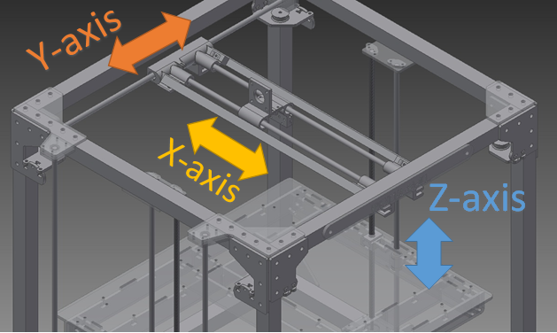

Figure 1 Enclosed 3D Printers

Square Shaped 3D printers are more prone to vibrations. Due to the reduction in frame material, the printer is an exchange between rigidity and expense. It is further easier to maintain and less bulky, but often is limited to a certain speed. The following figure shows the main axis of the machine. Technical literature on this type of printer is seldom. To be able to gain deeper perspective about the working, a prototype model was realized (Fig 3) and tested using degenerating condition of speed, mass and acceleration. By degeneracy, we imply the working condition and parameters at which the printer may start vibrating significantly. Many parts were 3D printed to reduce the overall cost to about USD$200. To attain a quantitative measure for comparison, a spectrum of vibration was recorded and average value has been evaluated. A mass of 100g was placed in form of data acquisition device. The base axis was moved straight by 20cm displacement at 30mm/s speed and 800mm/s2 acceleration. Suitable parameters were set using Marlin open source firmware, Arduino MEGA 2560 and Ramps 1.4 shield with A499 polulu stepper drivers driving nema 17 motors. The experimental setup is discussed more thoroughly in the later section.

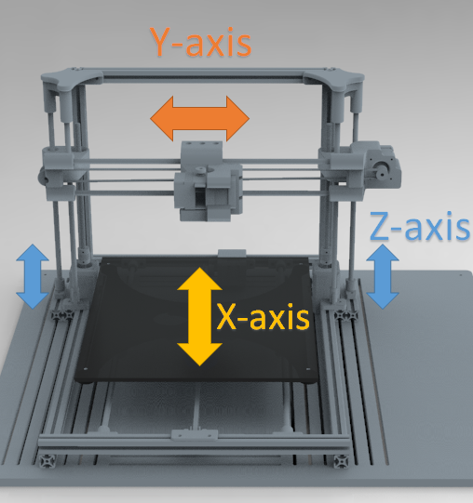

Figure 2 Square Frame 3D printers

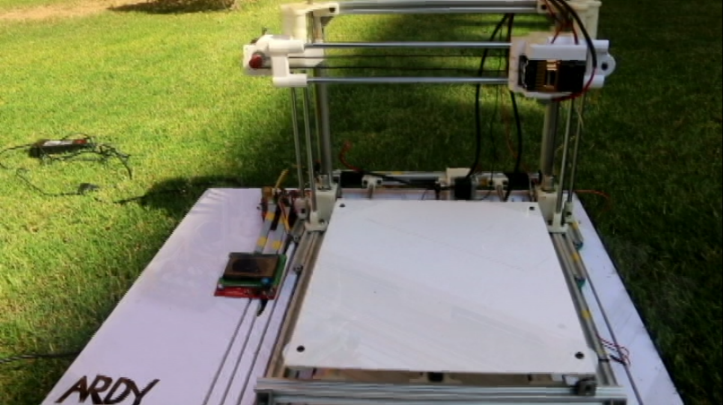

Figure 3 Realization of square frame 3d printer

In most cases the layers formed during deposition are easily noticeable. Quite often, due to the mechanical imperfections in the structure such as bearing quality and guide rod tolerances, the vibrations produced propagates throughout the whole structure, and sinking at the available mechanical openings. Moreover, since the rise of the 3D printing in consumer electronics, there has been a rise of additional feature, either integrated in the 3D printer itself (Zeus, 2017) or, being used as a different process or machine (Polymaker, 2017). This integration produces new forces that has to be taken care of, since these forces may further cause imperfections in the final product through vibrations.

## Cantilever Design (C-shape)

There are a few of Chinese, as well as foreign manufacturers who utilize the cantilever design. Most of them follow a same approach of machine designing process and the basic difference lies in the mechanical element being utilized to perform or assist the motion. It is known that almost all the cantilever designs are portable, such that it could be easily moved from place to another. They are also open to any kind of tinkering and flexibility. The main drawback in all these design is that they suffer from a small build volume, mainly constrained within 150mm to 180mm square build plate. Further exploration of the moving bed could also reveal that only one support mechanism is at work, which is either run using belt and toothed pulley based linear motion or linear rail guides and blocks, due to which their printing speed is also extremely limited to only 55mm/s (Anon., 2018), (Shuryan, 2018), (Coslow, 2018).

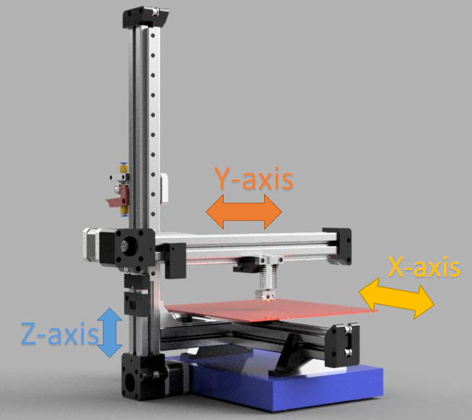

Figure 4 C-Shape 3D printer

Fig 4 shows the basic axis and direction. Similar to square shape 3D printer, literature review on cantilever (C-shape) printer is also rare. Most of the open source designs available online are limited to a speed of 60mm/s. This is primarily due to the mechanism supporting the X-axis (the base). To achieve a design which could work optimally at higher speed (about 100mm/s), an original design was realized and further advanced by improving the X-axis mechanism. Fig 5 shows the realized design. It utilizes the base following the CAD model shown in Fig 6.

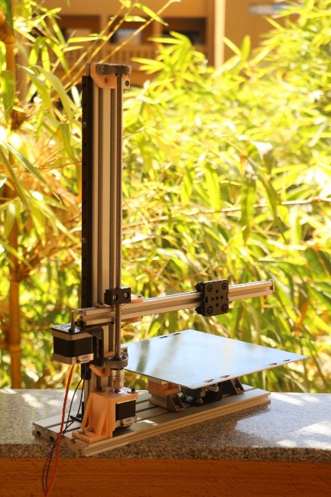

Figure 5 Realized C-shape 3D printed

## Review of existing C-shape 3D printers

Fig 6 shows the initial structure of the bed, which mostly performs the motion of one of the either planer axis of the printer. The 15x120mm aluminum extrusion, which mimics the mild steel base. Above it, lies the mechanical assembly consisting of linear bearing (which remains fixed with the base), guide rod and the guide rod support as the ends. The actuating motion of the bed is usually performed using a stepper motor driving a set of pulley and belt. The base support plate is fixed with the ends of each of the guide rod support, succeeding with an arrangement of springs, base plate and the heating bed. Fig 7 shows the actual design of Wanhao Duplicator i3 mini (Coslow, 2018).

The problem here is, the moving bed, which is connected with the base using only the linear bearing and its housing. This not only limits the size of the bed to 150x150mm, but also causes an extremely slow printing speed of about 60mm/s.

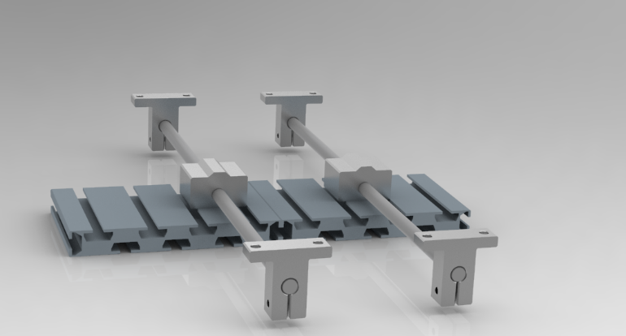

Figure 6 C-shape Base assembly: 1

Additional vibrations are created when certain designers chose to opt for direct extrusion method, which is rather seldom observed. This is mainly used when the printing process required high force to push the filament in the extruder, and produce a smooth filament flow through the heating nozzle. The alternative to this is using Bowden extrusion, in which the filament pushing mechanism and the heating mechanism are separated. The latter produces a tremendous decrease of weight in the moving carriage, while slightly reducing the force pushing the filament down the PTFE tube (Soared, 2017). The problem of using a direct drive becomes even more degrading when being utilized with a cantilever design, as shown in Fig 7. The extruder assembly is usually placed on the arm of the cantilever causing more load on the design structure, which may promote even more vibrations upon the movement of the axis.

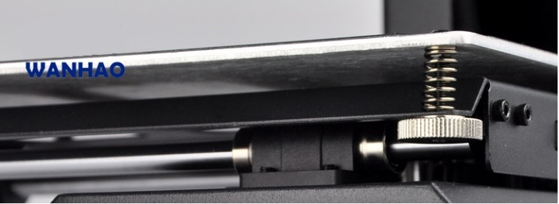

Figure 7 Wanhao Duplicator i3 mini base

Most of the discussed product utilizes belt drive, actuated using a stepper motor. The belt drives are either made using rubber polymer or steel wire enforced polymer. Although it is conventional to use belt drive in setting up desktop 3d printer, it is uncommon for a precision machine to utilize belt drive.

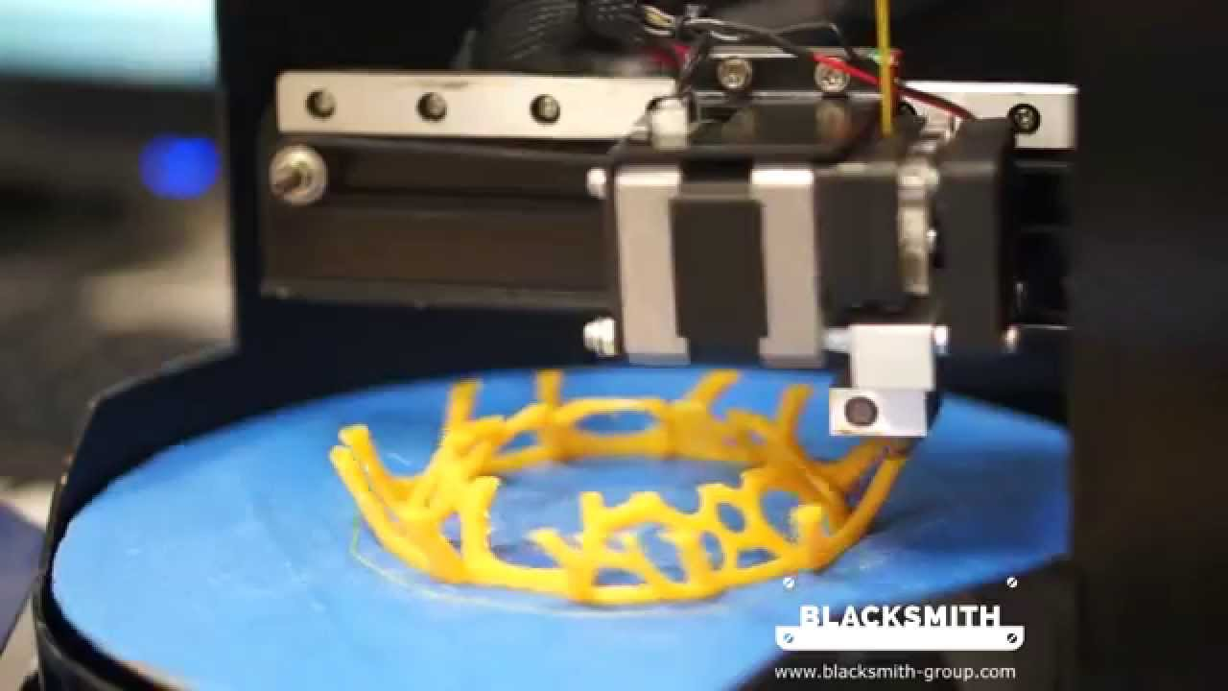

Figure 8 Direct Drive on Blacksmith Genesis

## Perfecting and Optimizing C-shape 3DP

The poor reception of the C-shape 3DP is due to its restrictions, which in turn evolve out of the design structure of the machine. Generally, in all 3d printers, three elements are considered. The z-axis carriage, which is the heaviest element (550g), followed by the x/y axis bed (530g). The lightest element is often the x/y axis which carries the extruder, in case of Bowden drive.

To improve the design of the C-shape 3DP, the speed of and the build volume should match to that of a standard desktop 3DP. The main problem which arises when increasing the build volume, and therefore the size of the build plate, is vibrations, as mentioned previously. The larger size of the build plate introduces more inertia. It was also observed that, although the vibrations may originate or source from many elements, e.g. bearing tolerances, guide rod tolerances and imperfections in the tooth of the pulley, they always migrate towards the ends of the build plate. Basically, instead of moving from the source to the sink (i.e. the base), the vibrations travel to any point which lies far from support. So to conclude, we could increase the number of constraints, or alternatively, decrease the weight of the build plate. Both conclusions were implemented altogether as shown in the following Fig 9.

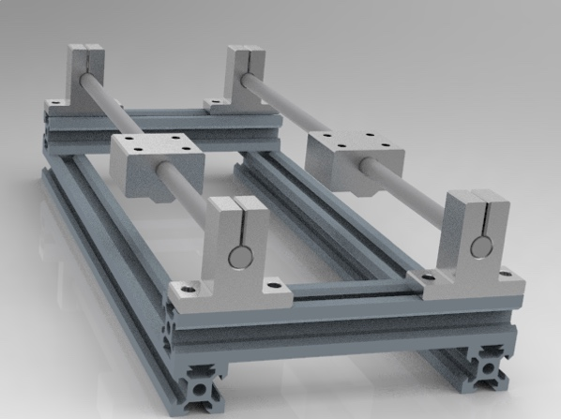

Figure 9 C-shape Base assembly: 2

The problem the above design poses are acquiring larger base area, which partially disturbs the aesthetic value of C-shape design. While some of the vibrations have been eliminated, a significant amount still accumulates near the end of the moving bed. With the accumulation of the printing material, i.e. PLA, on the build plate, the weight eventually increased to such a point, that high amplitude vibrations were observed. The resulting printed part is shown below.

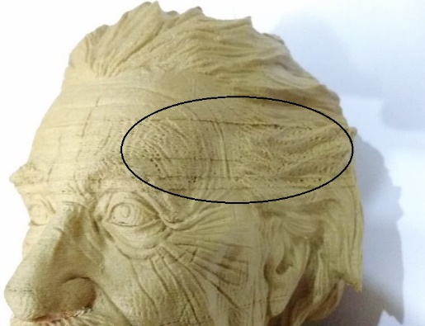

Figure 10 Einstein’s Bust reflecting defects due to Vibrations

To eliminate all the vibrations, particularly at the end of the build plate, yet another constraint was added*, but only at one end of the plate*, as shown below.

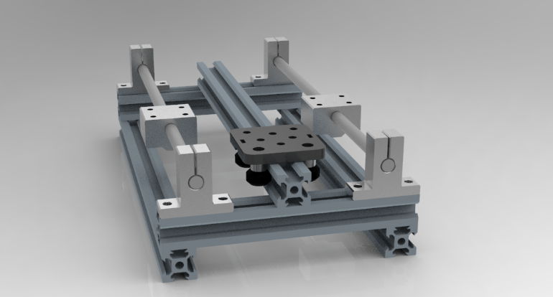

Figure 11 C-shape Base Assembly 3

The thought behind adding support at only one end is drawn from an impressing fact. Vibration are waves, with nodes and anti-nodes occurring in pairs. *When a new node is introduced in the wave structure, a corresponding node would also appear to form a pair at same distance from center, but in opposite direction*. Its implementation does reduce the vibrations significantly. The resulting structure could easily reflect the curves and depressions in the sculpture, without the absence of texture defects, as shown in the Fig 11.

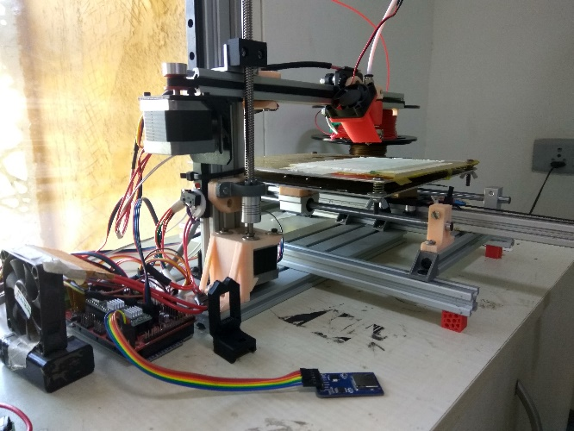

Figure 12 Realized Implementation

It should be noted that both the models were printed using same physical and printing speed of 60mm/s with an acceleration of 800mm/s2.

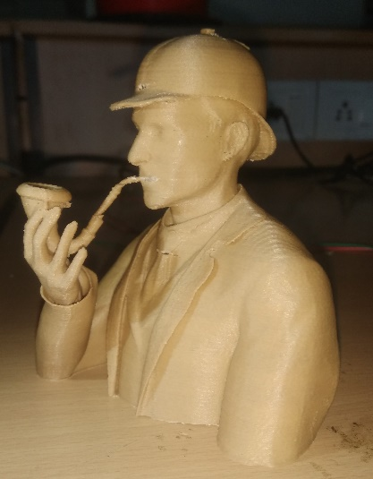

Figure 13 Bust using the C-shape base assembly: 3

# Experimental Setup

The kinematics of the 3D printer firmware works on GRBL source code. Since the motion of the printer is highly non-linear, a deterministic quantity is required to infer the vibrations involved during the motion. The vibrations occurring perpendicularly to the build plate were measured using MyRIO FPGA. MyRIO from national instruments provides an embedded accelerometer with 1000Hz sample rate. Using a small program on LabView to record the accelerometer reading in the z-axis, vibrations were measured for the square frame, the C-shape base 1 and C-shape base 3. Fig 14 shows the experimental setup involved.

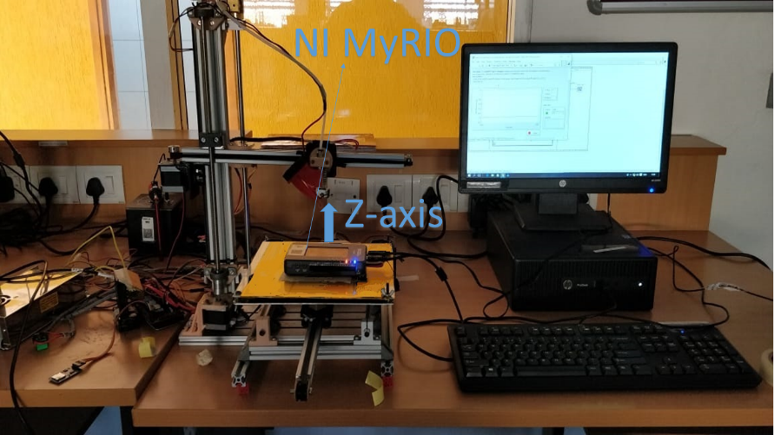

Figure 14 Experimental Setup

The mean of the resulting spectrums was constructed using bar graph. The following results were obtained.

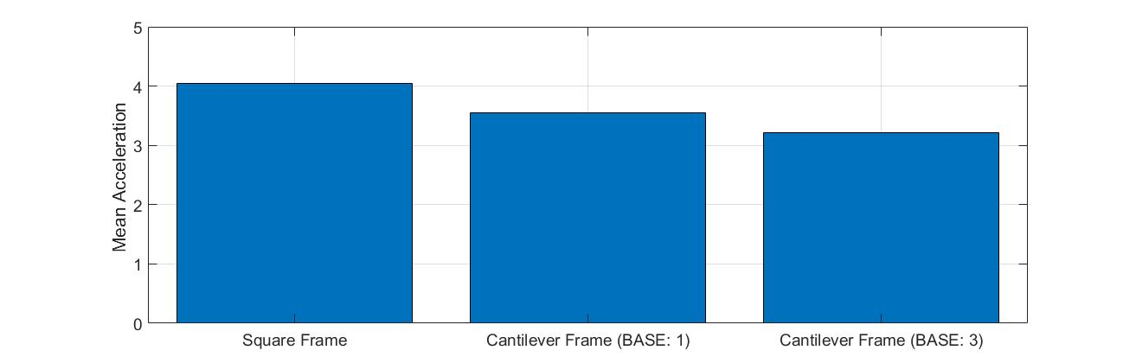

Figure 15 Mean of Different frame

The values clearly dictate that the vibrations reduced almost by a quartile. Most of the credit to the improvements observed is due to the use of standard metal fixtures and parts instead of the 3D printed ABS parts. An additional feature in the all the spectrum was also obtained. The spectrum showed different regions where vibrations were exceptionally lower to what was expected. When the moving bed passed through the middle of the X-axis, the vibrations were significantly different from rest of the region, as shown in Fig 16.

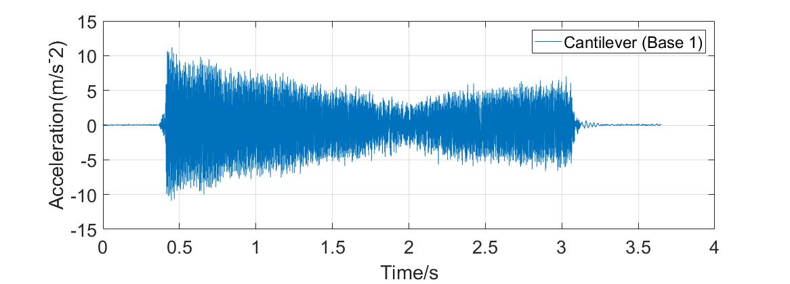

Figure 16 Vibrational Spectrum in C-shape

With this observation, it could also be concluded that the magnitude of the vibrations varies also with the position of build plate relative to the X-axis (axis of moving bed). Due to this non-uniform occurrence of vibrations, the quality of a single 3D printed part might differ. For e.g. if a part is covering up the full build volume of the build plate, its end may experience different layers and surface quality as compared to the part being printed in the center of the build plate. Given such a vibrational response from Cartesian based 3D printer, the following section discusses how polar coordinate based 3d printer compares under same scenario.

# Polar 3d Printer

The polar 3D printer, which works on cylindrical coordinates, is one genius feat in the machine designing of 3D printers. This basic mechanical assembly has the potential to develop further and establish itself as the standard desktop 3D printer, at the most affordable price. The working principle of the polar 3DP is very similar to C-shape 3D printer, with the exception that, the base of the polar 3DP rotates, instead of moving in linear to-fro motion. Although this design has existed in the market for about 3-4 years (Baguley, 2015) and, due to the conventional approach established by the bigger players to follow the box structure, the polar 3D printer, as well as the C-shape 3D printer are seldom used or discussed.

## Existing polar 3D printers

The Polar 3D™ (Baguley, 2015) integrates the movement of radial and the azimuthal into a single mechanism, i.e. the planer movement of pouring the PLA for a single layer is performed by a combined mechanism of linear as well as rotatory motion. It is an established fact that C-shape bed designs are most prone to vibrational defects. This is the reason why many desktop 3D printer producers choose to opt for Box/ enclosed 3D printers. In such printers, the base remains stationary for 98% of the printing time, as compared to 5% in the C-shape 3D printer. The Polar 3D™ printer instead, integrates another motion to the base, restricting its speed to only 50-60mm/s.

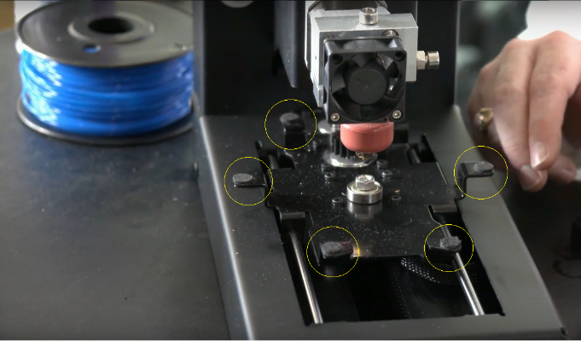

Figure 17 Fabric on support flange (in yellow circles)

Furthermore, the ends of the circular base are partially constrained using fabric dampers on the support flange of the base plate, as shown in Fig 17. As evident by the previous experiment with C-shape 3DP, a moving bed should be completely constrained from the center as well as the end of the base plate for successfully eliminating any vibrations being produced, otherwise the printing operation would be at a limited speed and also pose surface quality defects as the mass on the build plate keeps increasing.

Another 3d printer utilizing the cylindrical coordinate system was created by a NTU based start-up named Blacksmith. They restricted the movement of their base plate to only rotation, but for reason undisclosed*, have utilized direct extrusion,* Fig 8*.* Another intriguing feature of their printer is combination of a 3D scanner. This embedded design of scanner and printer is very analogous to the modern day desktop laser printer/scanner. Since the star-up was not able to perform as expected, the university had dissolved the organization.

## Design proposal

The focus of the design described is about perfecting the motion of the base, such that even at high speed, the surface quality of print is not compromised. The completely constrained motion of printer is achieved here by providing roller support at three ends, within close proximity to the outer rim and flat base support at the center of the plate, Fig 18.

The separation of base and cantilever also provides great flexibility towards improving the build volume. The stepper motors utilized for the movement of axis are inherently rotatory in motion. Converting this motion to linear form must include some loss in accuracy, especially when utilizing the belt drive mechanism. Instead in cylindrical system based 3D printer, the motor for the base is used without any conversion of motion. Although the accuracy added is insignificant at large scale, but at small scale of about 0.1-0.2mm, considerable change should be observed.

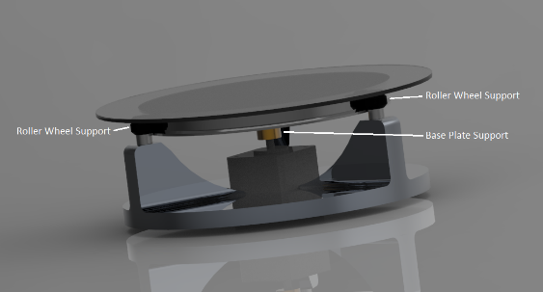

Figure 18 Proposed Base Design for Polar 3D printers

## Importance of Polar 3D printer

Many 3d printer manufacturers have introduced an embedded scanner. The drawback of using scanner in Cartesian system based 3D printer is the confliction of two different coordinate system. Scanner must be provided with rotating motor, which would rotate the object to be scanned, hence, most Cartesian 3d printers would include an extra motor for performing the said motion. (Zeus, 2017), (Anon., 2018). This is where Cylindrical system based 3DP optimize the utilization of resources.

Furthermore, many post processing machine have also been introduced for 3D printers, as a separate module. These machines essentially remove the layers from the final printed product by the chemical reaction of acetone with the used raw plastic (PLA or ABS). By using an ultrasonic mist producer, which could atomize many liquids to droplets of size in 10-30µm, the diffused droplets collect on different parts of the surface and thereby melt the protruding microlayers, causing the surface to display mirror finished polishing. The part is also continuously rotated such that the accumulation of droplets is ensured to occur all over the printed part. An extremely detailed article shows the step by step process of making such machines (MechEngineerMike, n.d.). The following figure highlights the important elements and their basic schematic connections.

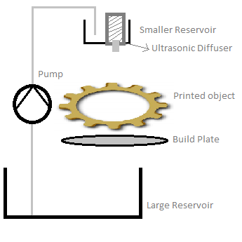

Figure 19 Schematic of Post-Processing Machine

# Conclusion

For any product to be a success, *the utility presented by a commodity should always exceed the created demand.* Basically, the product which is introduced to the consumers should always be self-explanatory. Without much intervention by the seller, a commodity should generate the utility autonomously, within the psychology of the buyers.

Repeatedly, the 3DP has attempted to reach the height of consumer market shelf, by making many acclamations, e.g. *“The 4rth industrial revolution”* (Schoffer, 2016), *“The new age manufacturing processes*” and many other remarks, but yet, its used mainly in automobile and aerospace industry. At most, it manages to reach the educational institutes and scientific research groups only. Though there are many reasons because of which, the 3DP is still far from having to fulfill its expectation, the main reason is its cost, on average, about 300$. A commodity worth said, should be equivalent to the revolution bought about by personal computers.

The approach to designing C-shape 3DP, Polar 3DP and many more upcoming improvements are attempts, which reduce the material costs and also utilize the resources at maximum. The standard enclosed/box design of 3DP, although provides high performance, hides the processing from the user, either partially or completely. The abstractness of 3DP is fully exposed for the C-shape 3DP, for the user to not only produce the parts, but also give a whole view of how the parts are being made. By having to integrate other feature as well, e.g. 3D scanning, 3DP post processing, the utility of the machine increases altogether.

The number of surviving 3DP start-ups in India are the ones focusing on platform based business model or a mix of platform and product based business model, i.e. a strict product based business venture is missing from the economic landscape of India. But, for a developing country, where most of the utilization of new technological forefront is focused on uplifting the rural community and support the development of demographic evolution by either government or non-governmental organizations, an affordable, adaptable and easily accessible 3D printing machine has no other substitute.

# Acknowledgement

We highly appreciate the support of Manipal University Jaipur, our family and friends for providing a stable ground for experimentation.

# References

Anon., 2016. *Direct Drive vs Bowden Extruder Guide and Calibration Tips.* [Online]   
Available at: https://pinshape.com/blog/direct-drive-vs-bowden-extruder-guide/  
[Accessed 2018].

Anon., 2017. *Polysmooth and Polysher.* [Online]   
Available at: http://www.polymaker.com/shop/polysmoothpolysher/  
[Accessed 2018].

Anon., 2017. *Zeus 3D printer and scanner.* [Online]   
Available at: https://www.zeus.aiorobotics.com/buy-now

Anon., 2018. *Flux delta+.* [Online]   
Available at: https://flux3dp.com/delta-plus/

Anon., 2018. *Monoprice MP Select Mini 3D Printer V2.* [Online]   
Available at: https://www.monoprice.com/product?p_id=21711  
[Accessed 2018].

Anon., 2018. *Print Quality Troubleshooting Guide.* [Online]   
Available at: https://www.simplify3d.com/support/print-quality-troubleshooting/

Anon., n.d. *Marlin.* [Online]   
Available at: http://marlinfw.org/

Anon., n.d. *PronterFace.* [Online]   
Available at: http://www.pronterface.com/

Baguley, R., 2015. *Polar 3D — 3D Printer Review.* [Online]   
Available at: https://www.tomsguide.com/us/polar-3d-printer,review-3206.html  
[Accessed 2018].

Coslow, T., 2018. *Wanhao Duplicator i3 Mini: Review the Facts.* [Online]   
Available at: https://all3dp.com/1/wanhao-duplicator-i3-mini-3d-printer-review/  
[Accessed 2018].

F. Al-Badour, M. S. ,. L. C., 2011. Vibration analysis of rotating machinery using time–frequency analysis and wavelet techniques. *Mechanical System and Signal Processing,* pp. 2083-2101.

Francois Decuir, K. P. B. H., 2016. Mechanical Strength of 3-D Printed Filaments. *CPS.*

Gartner, 2019. *Gartner says worldwide shipments of 3D printers to reach more than 490,000 in 2016.* [Online]   
Available at: www.gartner.com/newsroom/id/3139118  
[Accessed 2017].

Hemlock, C., n.d. *Chris's 3D printing project.* [Online]   
Available at: https://chayesthakore.wordpress.com/about/  
[Accessed 2018].

Humphrey, 2003. Globalization and supply chain networks: the auto industry in Brazil and India. *Global Networks,* 2(3), pp. 121-141.

Jones, M., 2018. *3D Printer Firmware – Which to Choose and How to Change It?.* [Online]   
Available at: https://all3dp.com/2/3d-printer-firmware-which-to-choose-and-how-to-change-it/  
[Accessed 2018].

Ke Ronga, D. P. W. C., 2018. Business models dynamics and business ecosystems in the emerging 3D. *Technological Forecasting and Social Change,* p. 12.

Kellner, 2015. *The first FAA cleared 3D printed part to fly in a commercial jet engine from GE,* s.l.: GE Reports article.

McCue, T., 2018. *Wohlers Report 2018: 3D Printer Industry Tops $7 Billion.* [Online]   
Available at: https://www.forbes.com/sites/tjmccue/2018/06/04/wohlers-report-2018-3d-printer-industry-rises-21-percent-to-over-7-billion/#7f760462d1a4

MechEngineerMike, n.d. *Automated Ultrasonic Misting 3D Print Polisher PRO.* [Online]   
Available at: https://www.instructables.com/id/Automated-Ultrasonic-Misting-3D-Print-Polisher-PRO/

Nair, A. A., 2015. *Forget VCs, Indian govt funds this 3D printing startup.* [Online]   
[Accessed 2018].

Peermohamed, S. A. &. A., 2018. *The future is 3D: India witnesses spurt in additive manufacturing.* [Online]   
Available at: https://www.business-standard.com/article/companies/the-future-is-3d-india-witnesses-spurt-in-additive-manufacturing-118080801301_1.html  
[Accessed 2018].

PONTE, M. R. A. S., n.d. From smiling to smirking? 3D printing, upgrading and the restructuring of global value chains.

Pyper, J., 2014. *World's First Three-Dimensional Printed Car Made in Chicago.* [Online]   
Available at: https://www.scientificamerican.com/article/world-s-first-three-dimensional-printed-car-made-in-chicago/  
[Accessed 2018].

Quintans, D., 2017. *Diagnosing and fixing ringing versus vibration artefacts.* [Online]   
Available at: http://www.desiquintans.com/ringing

Schoffer, F., 2016. *Is 3D Printing The Next Industrial Revolution?.* [Online]   
Available at: https://techcrunch.com/2016/02/26/is-3d-printing-the-next-industrial-revolution/

Search, E. P., n.d. *3d printing process patent.* [Online]   
Available at: https://worldwide.espacenet.com/publicationDetails/inpadocPatentFamily?CC=US&NR=5900207A&KC=A&FT=D&ND=6&date=19990504&DB=EPODOC&locale=en_EP

Shuryan, A., 2018. *Creality CR-8 2 in 1 3D Printer Review.* [Online]   
Available at: https://3dpc.tech/creality-cr-8-2-in-1-3d-printer-review/

Soared, I., 2017. *DIY 3D Printer from scratch – Bowden vs Direct Drive.* [Online]   
Available at: https://3dprinterchat.com/2017/05/bowden-vs-direct-drive/  
[Accessed 2018].

Stevenson, K., 2017. *The Hangprinter: A Frameless 3D Printer.* [Online]   
[Accessed 2018].

Team, P. R., n.d. *Prusa.* [Online]   
Available at: https://www.prusa3d.com/

Tech2c, 2017. *THIS IS Y.* [Online]   
Available at: https://www.youtube.com/watch?v=AKTvykTPjQw  
[Accessed 2018].

Walker, K., 2014. *The intellectual property challenges from 3D printing.* [Online]   
Available at: https://www.computerweekly.com/opinion/The-intellectual-property-challenges-from-3D-printinghttps://www.computerweekly.com/opinion/The-intellectual-property-challenges-from-3D-printing

Zbigniew Pilch, J. D., 2015. The impact of vibration of the 3D printer table on the quality of print. *IEEE.*

1.